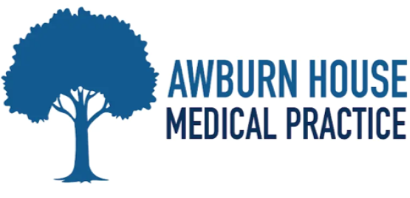
PRACTICE SUMMARY JANUARY 2026
Below is our practice summary for the month of January .
99% of patients rated their experience as good or very good as part of the friends & family test
Thank you to all our patients that take time to give us feedback, whether that be via the Friends & Family questionnaire

TOTAL PRACTICE LIST SIZE – 6192  TOTAL FACE TO FACE GP APPOINTMENTS – 758  TOTAL GP TELEPHONE CONSULTATIONS – 333  TOTAL NURSE & HCA APPOINTMENTS – 664  TOTAL ON-LINE TRIAGE FORMS PROCESSED – 455  TOTAL APPOINTMENTS NOT ATTENDED – 52  TOTAL PRESCRIPTIONS PROCESSED – 2024  WE HAVE RECEIVED 4,120 PHONE CALLS.  AVERAGE TIME TO ANSWER A CALL 43’s | 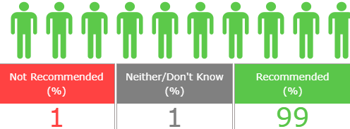  The ease of getting an appointment and having a very understanding doctor  Staff are brilliant, always polite and professional. Quick service  Awburn House has always been friendly and efficient. There is now a new status and method governing appointments, but it is still in empathy with its patients  Appointment on time, pleasant staff overall a good service.  I am registered blind and the staff were very helpful  Friendly staff, nice surroundings, short wait, great doctor.  Today was my first visit to the surgery, and I experienced exceptional kindness and compassion throughout. I was made to feel very welcome and valued as a patient

