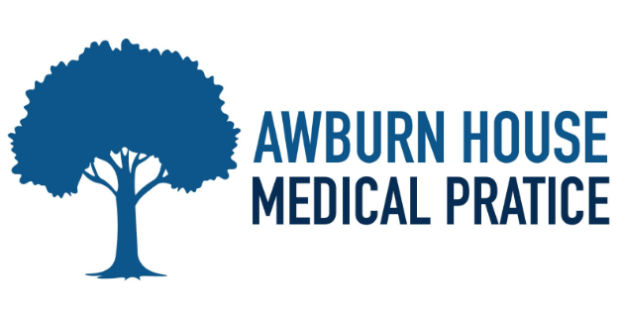
WELCOME TO OUR NEWSLETTER
Winter 2026

EXCITING NEWS

We’re pleased to inform you that, starting December, there will be changes to the working days of our General Practitioners (GPs). Please see the updated schedule below. These changes are designed to improve appointment availability and ensure continuity of care for all our patients
- Dr. Darah Burke: Available on Monday, Tuesday, and Wednesday.
- Dr. Seema Ansari: Available on Monday & Friday
- Dr. Karl Boulton: Available on Monday, Tuesday, Wednesday &Thursday,
- Dr. Lewis-Hanna: Available on Wednesday, Thursday, and Friday.
- Paramedic Luke Routeledge: Available on Thursday.
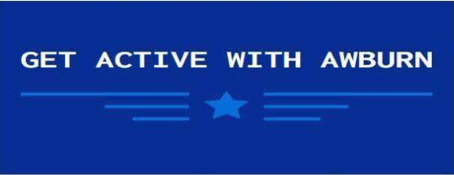

Did you know Awburn House has started its very own walking group. The group meets once a month on a Thursday. If you are interested, please contact reception and they will give you all the details

NHS APP INFORMATION

We encourage all our patients to download and use the NHS App. This app provides a simple and secure way to access a range of NHS Services directly from your smartphone or tablet. With the NHS App, you can book and manage appointments, order repeat prescriptions, view your GP health record, and even access NHS 111 online for medical advice. The app is available for download on both the google play store and the Apple Store for more information, visit https://www.nhs.uk/nhs-app/

As we are no longer allowing pharmacies to order your medication on your behalf, why not register for online access to your care record. It’s by far the easiest way to order your medicine. You can also book an appointment online, check your blood test results, view your immunisations and consultations etc. We now have 23% of our patients using online access. Just ask at reception.



YOUNG ADULTS

Do we have your correct contact details? Is the mobile number on your record yours or is it still your parent’s number? Check what details we hold for you and update your records with reception.
On-line Consultations important information–

As part of a government initiative, all GP surgeries are now required to offer online consultations. These provide a convenient way to manage routine appointment requests and handle administrative queries such as referral letters, sick note requests, or medication requests (for medicines you have previously been prescribed).
Please note: Online consultations must not be used for emergencies or urgent appointment requests, and they are not intended for conversational purposes. Only one online consultation can be submitted per patient per day.
This service helps us respond more efficiently and reduce waiting times, ensuring you receive the care and support you need as quickly as possible.

Your Feedback Matters
Over the past few months, our Friends and Family feedback has shown that 97% of patients are happy with the service we provide – thank you for your continued support! We are always looking for ways to improve our services. Sometimes the changes we implement are mandatory to meet national requirements, but we work hard to ensure these changes comply with our contract while still providing you with the very best care.
IMPORTANT INFORMATION –


Every 3rd Thursday of the month the surgery will close at 12.30PM for relevant training. If you need medical advice whilst the surgery is closed, please contact NHS 111, visit a walk-in-centre or consult your local pharmacy

THE PRACTICE WILL BE CLOSED ON THE FOLLOWING DATES:

Thursday 15th January 2026
Thursday 19th February 2026
Thursday 19th March 2026

