
PRACTICE SUMMARY OCTOBER 2025
Below is our practice summary for the month of October.
97% of patients rated their experience as good or very good as part of the friends & family test
Thank you to all our patients that take time to give us feedback, whether that be via the Friends & Family questionnaire

TOTAL PRACTICE LIST SIZE – 6221  TOTAL FACE TO FACE GP APPOINTMENTS – 861  TOTAL GP TELEPHONE CONSULTATIONS – 367  TOTAL NURSE & HCA APPOINTMENTS – 686  TOTAL ON-LINE TRIAGE FORMS PROCESSED – 362  TOTAL APPOINTMENTS NOT ATTENDED – 48  TOTAL PRESCRIPTIONS PROCESSED – 2057  WE HAVE RECEIVED 4,614 PHONE CALLS.  AVERAGE TIME TO ANSWER A CALL 50’s | 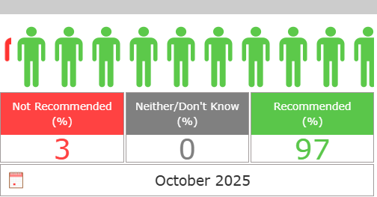  Very easy to book in and the whole procedure was smooth  The surgery was efficient and the staff polite  Friendly, not rushed listened to.  Staff very pleasant, doctors listen to you without pressure to get rid of you  Quick, efficient professional service delivered in a friendly manner

