
PRACTICE SUMMARY NOVEMBER 2025
Below is our practice summary for the month of November.
96% of patients rated their experience as good or very good as part of the friends & family test
Thank you to all our patients that take time to give us feedback, whether that be via the Friends & Family questionnaire

TOTAL PRACTICE LIST SIZE – 6221  TOTAL FACE TO FACE GP APPOINTMENTS – 764  TOTAL GP TELEPHONE CONSULTATIONS – 339  TOTAL NURSE & HCA APPOINTMENTS – 657  TOTAL ON-LINE TRIAGE FORMS PROCESSED – 321  TOTAL APPOINTMENTS NOT ATTENDED – 46  TOTAL PRESCRIPTIONS PROCESSED – 1955  WE HAVE RECEIVED 4,614 PHONE CALLS.  AVERAGE TIME TO ANSWER A CALL 50’s | 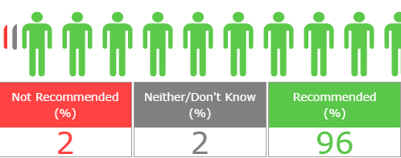  We Understand Your Concerns About Parking  We have received negative reviews due to the parking issue we are experiencing at the moment.  We know how important it is for our patients to have access to parking when visiting the surgery. Although the car park is owned by Awburn House Medical Practice, we’ve recently experienced challenges with neighbouring households using it as their personal parking space.  We are actively addressing this issue and have advised those involved that the car park is for patients only. Unfortunately, this message hasn’t been fully respected yet, but please be assured we are continuing to work on a solution.

