
PRACTICE SUMMARY DECEMBER 2025
Below is our practice summary for the month of December.
97% of patients rated their experience as good or very good as part of the friends & family test
Thank you to all our patients that take time to give us feedback, whether that be via the Friends & Family questionnaire

TOTAL PRACTICE LIST SIZE – 6221  TOTAL FACE TO FACE GP APPOINTMENTS – 785  TOTAL GP TELEPHONE CONSULTATIONS – 473  TOTAL NURSE & HCA APPOINTMENTS – 622  TOTAL ON-LINE TRIAGE FORMS PROCESSED – 397  TOTAL APPOINTMENTS NOT ATTENDED – 54  TOTAL PRESCRIPTIONS PROCESSED – 2055  WE HAVE RECEIVED 3,801 PHONE CALLS.  AVERAGE TIME TO ANSWER A CALL 40’s | 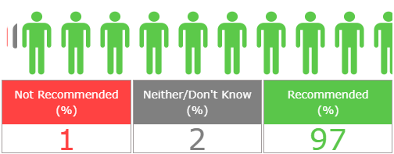  Both the nurse and doctor that I saw today are very friendly and professional thank you.  Appointment on time, friendly nurse  Had excellent service from reception and Dr.Burke.  Care and attention given by all staff Thank you  I saw Dr Burke who is always kind, listens and is very thorough and always reassuring.  I was listened to and got meds I needed. Got in on the day  As usual everyone very polite and friendly. Very good.

