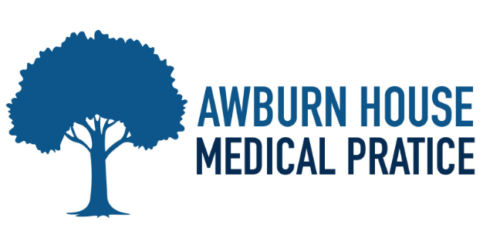
WELCOME TO OUR NEWSLETTER
SPRING 2025

EXCITING NEWS
We are pleased to inform you about the new General Practitioners (GPs) joining our practice starting June 2025. Below are the details of their schedules:
- Dr. Darah Burke: Available on Monday, Tuesday, and Wednesday.
- Dr. Seema Ansari: Available on Monday.
- Dr. Karl Boulton: Available on Monday, Wednesday, and Friday.
- Dr. Lukas Urbonas: Available on Tuesday and Thursday.
- Dr. Lewis-Hanna: Available on Wednesday, Thursday, and Friday.
- Paramedic Luke Routeledge: Available on Thursday.
We are excited to welcome these new professionals to our team and are confident that their expertise will greatly benefit our community.
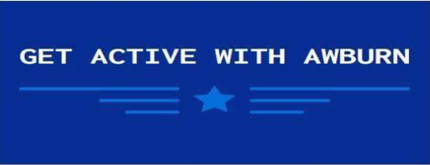

Did you know Awburn House has started its very own walking group. The group meets once a month on a Thursday. If you are interested, please contact reception and they will give you all the details

NHS APP INFORMATION

We encourage all our patients to download and use the NHS App. This app provides a simple and secure way to access a range of NHS Services directly from your smartphone or tablet. With the NHS App, you can book and manage appointments, order repeat prescriptions, view your GP health record, and even access NHS 111 online for medical advice. The app is available for download on both the google play store and the Apple Store for more information, visit https://www.nhs.uk/nhs-app/

As we are no longer allowing pharmacies to order your medication on your behalf, why not register for online access to your care record. It’s by far the easiest way to order your medicine. You can also book an appointment online, check your blood test results, view your immunisations and consultations etc. We now have 23% of our patients using online access. Just ask at reception.



YOUNG ADULTS

Do we have your correct contact details? Is the mobile number on your record yours or is it still your parent’s number? Check what details we hold for you and update your records with reception.

TEST RESULTS

Most of you are probably aware that we now text you when we have the results of your blood tests. If the text message asks you to contact the surgery, we would be grateful if you could telephone after 1pm. This will free up the telephone lines during the busy morning surgery and also give reception staff more time to help you.

If the doctor needed to speak to you urgently regarding your results we would never notify you by text, so please don’t feel you have to speak to someone immediately.

IMPORTANT INFORMATION –

Every 3rd Thursday of the month the surgery will close at 12.30PM for relevant training. If you need medical advice whilst the surgery is closed, please contact NHS 111, visit a walk-in-centre or consult your local pharmacy

THE PRACTICE WILL BE CLOSED ON THE FOLLOWING DATES:

MAY – 5TH & 26TH
AUGUST – 25TH

If you need help or assistance on these days please choose from the following:
Ashton Primary Care Centre – open 7 days a week, 365 days a year – 0161 342 7000
Dial 1-1-1 if you need help fast – but it’s not an emergency
Your local pharmacy can offer help and advice on many minor ailments.

